**INNOVATION AND ENTREPRENEURSHIP**

**UTA025**

**Lab Assignment 1**

***Submitted by:***

**Name:** SHREEYA CHATTERJI

**Roll Number:** 102103447

**Group:** 3CO16



***Entrepreneurs Chosen:***

Sumilan Chatterjee

&

Sadhan Singla

**SUMILAN CHATTERJEE**

*- Rangoor Creation*

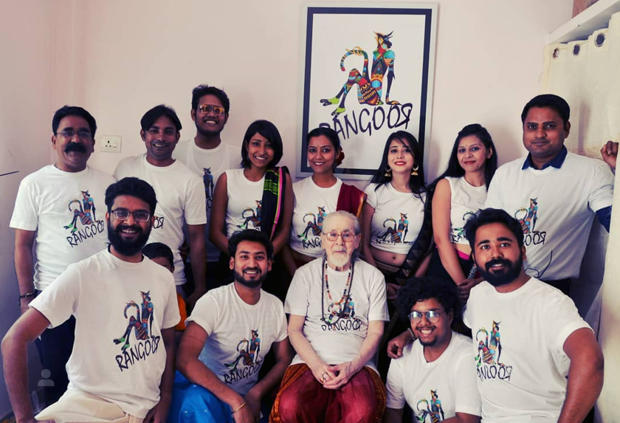

**About Sumilan Chatterjee:**

Sumilan Chatterjee's educational background and entrepreneurial journey paint a remarkable story of dedication to Mass Communication and a significant impact on Hindi Theatre through his venture at Rangoor Creation Foundation.

Sumilan holds a postgraduate degree in Mass Communication from Banaras Hindu University, with a specialization in Television, Radio, and Film. His engagement in All India Radio and local radio stations, coupled with numerous theatre productions and participation in dramas, debates, and workshops, laid the foundation for his multifaceted career.

In addition to his role as Content Leader at Mirchi, Sumilan is also a Co-Founder of Rangoor Creation Foundation. Situated in Varanasi, this venture demonstrates his entrepreneurial spirit in establishing a Theatre Group dedicated to the betterment of Hindi Theatre. Over the past 7 years, Rangoor Creation Foundation, under Sumilan's leadership, has produced a series of noteworthy plays, including "**Sandhya Chaaya**," "**Taj Mahal Ka Tender**," "**Jis Lahore Nahi Dekhya Wo Jamyai Nahi**," and several others.

This entrepreneurial journey at Rangoor Creation Foundation showcases Sumilan's commitment to contributing to the cultural and artistic landscape. Through productions that span various themes and genres, he has not only brought engaging theatre to audiences but has also played a pivotal role in fostering and promoting Hindi Theatre in the Varanasi area.

Sumilan Chatterjee's journey from his educational pursuits to his roles at Mirchi and as a Co-Founder at Rangoor Creation Foundation highlights his versatility, leadership, and significant contributions to both the media and theatre domains. His entrepreneurial endeavours at Rangoor Creation Foundation underscore his commitment to cultural enrichment and the promotion of Hindi Theatre in the region.

**How I know Sumilan Chatterjee:**

Sumilan Chatterjee is not just a professional acquaintance but holds a special place in my life as my cousin. This familial connection has granted me a unique and privileged insight into his professional journey, allowing me to closely observe and appreciate his notable work and endeavours.

**Sumilan Chatterjee’s Big Five Personality Analysis**

**His Answers:**

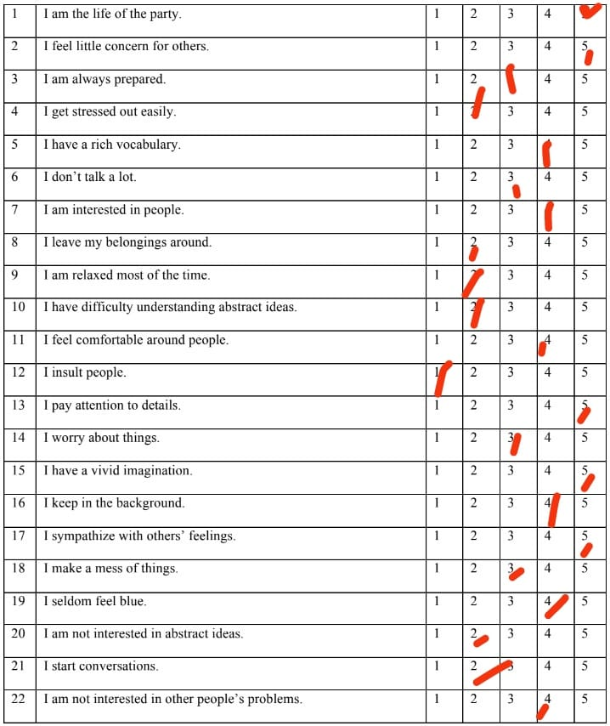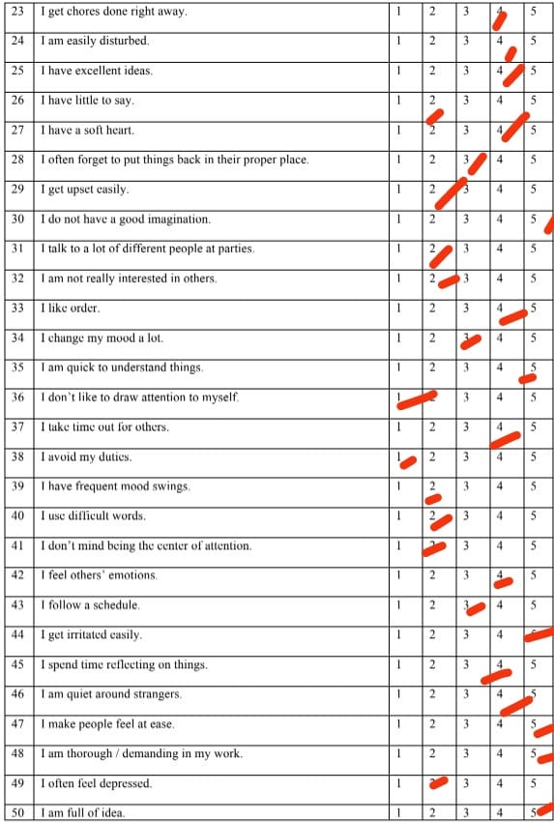

**Sumilan’s Test Scores:**

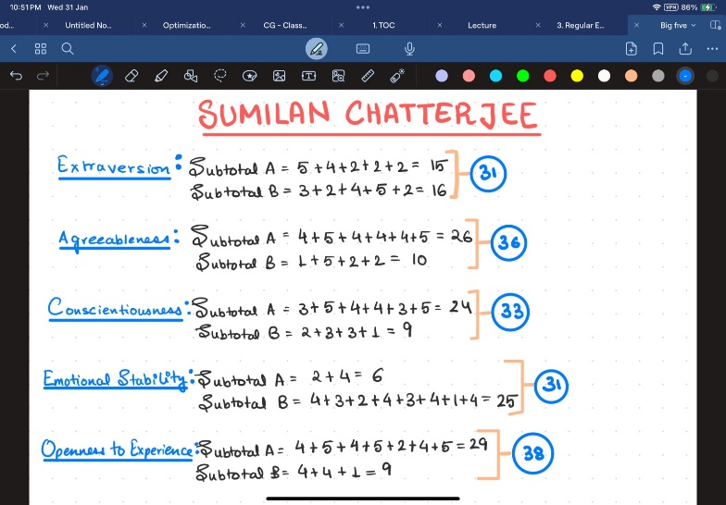

**Analysing Sumilan Chatterjee’s personality:**

1. **Extraversion(31)- HIGH**
   * Knowing him personally the high score truly justifies his extroverted personality as he is an easy to talk to and is very outgoing and friendly. His large network is a result of this personality trait
2. **Agreeableness(36) – HIGH**
   * Sumilan is an adapter with a trusting and straightforward personality. This trait helps him talk to theatre companies and comes very handy in negotiating prices and change as and when required according to the needs of his theatre group and all the stakeholders in his plays and movies.
3. **Conscientiousness(33) – HIGH**
   * In the face of challenges, Sumilan Chatterjee exhibits remarkable resilience and tenacity. From managing lights and acting to overseeing logistics, Sumilan's high conscientiousness ensures that every detail is thoroughly attended to. This dedication plays a pivotal role in ensuring the flawless execution of a drama in front of an audience, where precision and perfection are paramount.
4. **Emotional Stability(31) -HIGH**
   * Sumilan Chatterjee's high emotional stability and resilience shine in the unpredictable world of theatre. His composed demeanour and ability to navigate challenges inspire confidence, showcasing a remarkable capacity to bounce back from setbacks.
5. **Openness to Experience(38) – HIGH**
   * Sumilan Chatterjee's open-minded and imaginative spirit fuels his explorative nature, combining humour, inventiveness, and curiosity in a creative blend that enriches his diverse ventures and endeavours. His dynamic approach embraces novelty with a flair for imaginative solutions and a humorous touch.

**Conclusion:**

Sumilan Chatterjee exhibits a remarkable alignment with the Big Five personality traits, especially excelling in openness to experience, conscientiousness, and emotional stability. These characteristics aptly suit his role in the unpredictable realm of drama, where his imaginative, meticulous, and emotionally resilient nature contributes to his success and effectiveness in the very unpredictable world of theatre and drama.

**SADHAN SINGLA**

*- NGO Muskan*

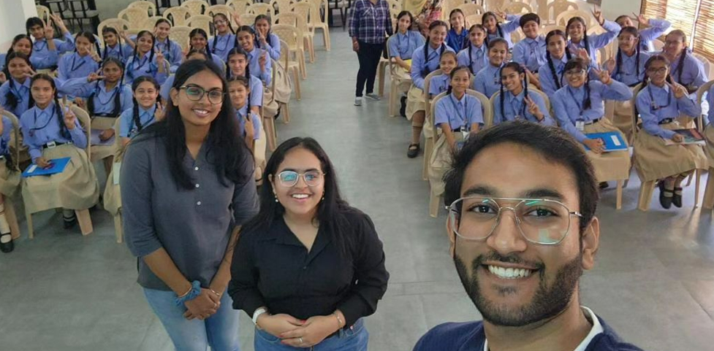

**About Sadhan Singla:**

Sadhan Singla, is the enterprising founder of NGO Muskan and a fellow third-year student at Thapar University, possesses a distinct entrepreneurial personality that is both inspiring and impactful. His journey reflects a commitment to addressing societal issues, particularly the stigma surrounding menstruation.

A visionary entrepreneur, Sadhan has demonstrated a keen understanding of the pressing challenges related to menstrual health and hygiene. His commitment to creating a society where menstruation is not taboo and women are not discriminated against showcases his passion for societal change.

One notable aspect of Sadhan's entrepreneurial personality is his holistic approach. Beyond addressing menstrual health, Muskan, under his leadership, focuses on H.E.F.A.O. - Health care, Environment restoration, Food, and Animal welfare. This reveals a comprehensive vision aimed at improving the overall well-being of both people and animals.

In conclusion, Sadhan Singla's entrepreneurial personality is marked by a visionary outlook, a commitment to social impact, and the ability to address multifaceted issues. His journey reflects the power of young individuals to challenge societal norms and actively contribute to the betterment of society.

**How I know Sadhan Singla:**

Having worked closely with Sadhan as the tech head in the same organization, I've witnessed his leadership firsthand. This provided me the opportunity to closely work in a budding startup and contribute to the society through the NGO using my tech skills.

**Sadhan Singla’s Big Five Personality Analysis**

**His Answers:**

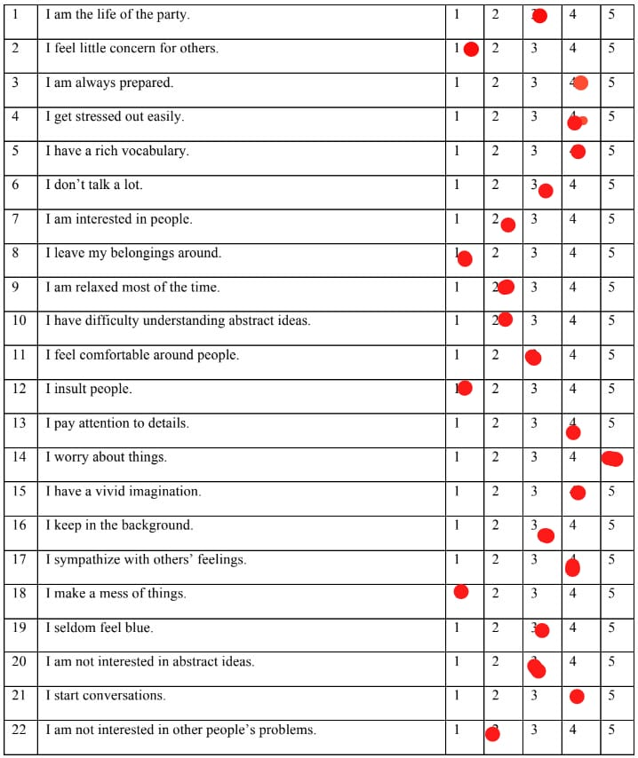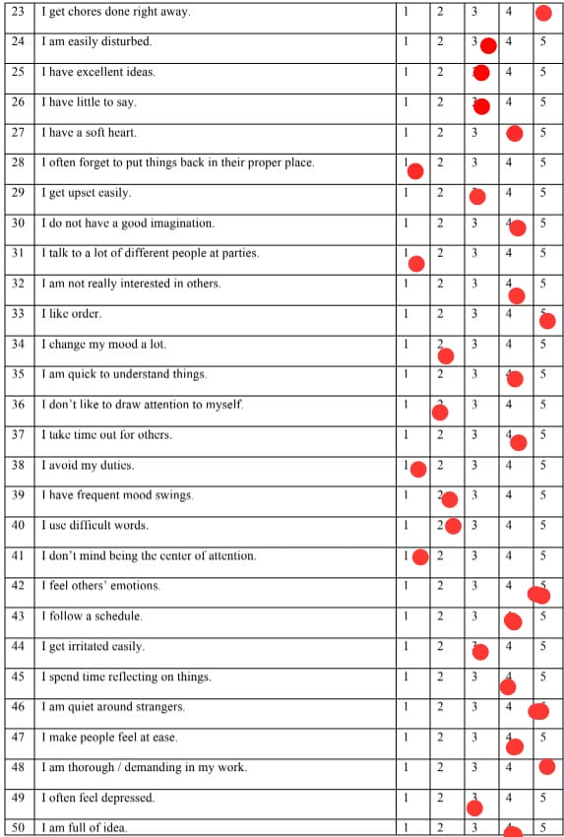

**Sandhan’s test scores:**

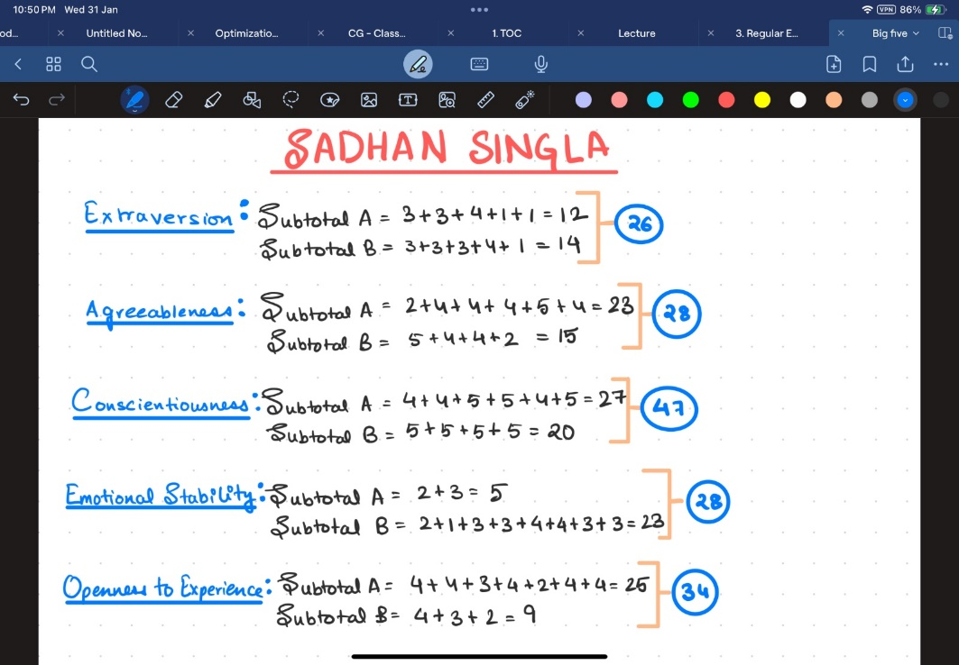

**Analysing Sadhan’s Personality:**

1. **Extraversion(26)- MEDIUM**
   * Sadhan’s medium extraversion score contributes to his effectiveness as an entrepreneur. He has a balanced social approach, reflected in his interactions as a friend, enables him to build meaningful connections, fostering collaborations and support networks that amplify the impact of his visionary initiatives at Muskan.
2. **Agreeableness(28)- MEDIUM**
   * Sadhan Singla's medium agreeableness score complements his entrepreneurial endeavours, fostering effective collaboration and communication. Having worked closely with him, I've observed that this balanced agreeableness enables him to promote a harmonious and cooperative environment essential for addressing societal challenges through initiatives like Muskan.
3. **Conscientiousness(47)- VERY HIGH**
   * Having closely observed Sadhan Singla, I've noted his high conscientiousness, which aligns seamlessly with his entrepreneurial pursuits. This trait ensures meticulous planning and execution, contributing to the ongoing success and impactful initiatives of Muskan.
4. **Emotional Stability(28)- MEDIUM**
   * I have personally noticed how Sadhan’s emotional stability contributes positively to his role as an entrepreneur. His balanced emotional outlook allows him to handle the inevitable ups and downs of entrepreneurial ventures with resilience, ensuring steady decision-making and effective leadership in challenging situations. Being able to empathise is something he does better than most people I have ever met and this makes him perfect for the role as the CEO of a startup that wants to make a societal change.
5. **Openness to Experience(34)- HIGH**
   * Sadhan Singla's high openness to experience propels his success in NGO entrepreneurship. This trait fuels innovative solutions, creative approaches, and a forward-thinking mindset, enabling him to effectively address societal issues through Muskan.

**Conclusion:**

Sadhan Singla's Big Five personality traits are clearly reflected in his role as an entrepreneur steering Muskan, an NGO dedicated to societal change. His elevated openness fosters innovation, conscientiousness ensures detailed planning, agreeableness nurtures effective collaboration, emotional stability supports resilience, and a balanced extraversion score facilitates meaningful connections. This holistic alignment underscores the effectiveness of his entrepreneurial strategy in spearheading impactful societal transformations.